Project
  - Deadline: Monday 09/08/2026 @ 23:59
[Total Mark is 20]

Introduction to Database
xxxxx
Instructions:
- You must submit two separate copies (one Word file and one PDF file) using the Assignment Template on Blackboard via the allocated folder. These files must not be in compressed format.
- It is your responsibility to check and make sure that you have uploaded both the correct files.
- Zero mark will be given if you try to bypass the SafeAssign (e.g. misspell words, remove spaces between words, hide characters, use different character sets, convert text into image or languages other than English or any kind of manipulation).
- Email submission will not be accepted.
- You are advised to make your work clear and well-presented. This includes filling your information on the cover page.
- You must use this template, failing which will result in zero mark.
- You MUST show all your work, and text must not be converted into an image, unless specified otherwise by the question.
- Late submission will result in ZERO mark.
- The work should be your own, copying from students or other resources will result in ZERO mark.
- Use Times New Roman font for all your answers.
Student Details: CRN:
Name:  Name: Afnan Abulmajed Muthaffar  Name:  Name: |  | ID:  ID: 240031675  ID:  ID:

Project Instructions
- You can work on this project as a group (minimum 3 and maximum 4 students). Each group member must submit the project individually with all group member names mentioned on the cover page.
- This project worth 20 marks and will be distributed as in the following:
  - Database Design. (6 marks)
  - Database Implementation. (6 marks)
  - SQL Operations. (6 marks)
  - Project Reflection. (2 marks)
- Each leader in the group must submit one report about their chosen Project via the Blackboard (Email submission will not be accepted and will be awarded ZERO marks) containing the following:
- Task 1 : database design
- Task 2: database implementation
- All requested queries/results
- Screenshots from MySQL (or any other software you use) of all the tables after population and query results.
- Reflection (300–500 words) describing the team's experience, challenges, design decisions, and AI usage (if applicable).
- Submit one SQL file containing the complete database implementation, including database creation, tables, data insertion, required queries, VIEW, and TRIGGER.
- Submit a GitHub (or GitLab) repository containing the complete project with regular commits and meaningful commit messages.
- Submit a progress report describing the completed work, key decisions, challenges, future plan, and contribution of each group member.
- Include links to the live report document, GitHub/GitLab repository, and Google Colab notebook (if applicable) in the Project Artifacts section of the final report.
- You are advised to make your work clear and well presented; marks may be reduced for poor presentation. This includes filling in your information on the cover page.
- You MUST show all your work, and text must not be converted into an image unless specified otherwise by the question.
- Late submission will result in ZERO marks being awarded.
- The work should be your own. Copying from students or other resources, including AI software, will result in ZERO marks.

Project Description
Design and Implementation of a Smart Clinic Database System
Learning Outcome(s):

CLO1, CLO2, CLO3, CLO4, CLO5

A private clinic currently manages its patient information manually, making it difficult to organize appointments, treatments, and payments. The clinic has decided to develop a database system to improve data organization and retrieval.
Your team is required to design, implement, and test a complete relational database using the concepts learned throughout this course. The project should demonstrate your understanding of database design, ER/EER modeling, relational mapping, SQL implementation, and advanced SQL queries. The project must be completed using MySQL.
Task

Task 2 – Database Implementation (6 Marks)
Complete the following tasks using MySQL. Include screenshots of both your SQL code and the corresponding output (results) for each task:
- Create the database and all required tables.
- Use appropriate data types and constraints (PRIMARY KEY, FOREIGN KEY, NOT NULL, UNIQUE, etc.).
- Insert at least 5 records into each main table.

Answer:
Task 2 – Database Implementation
Step 1: Create Database
CREATE DATABASE clinicdb;
USE clinicdb;

-- =========================
-- Patient
-- =========================
CREATE TABLE Patient(
PatientID INT AUTO_INCREMENT PRIMARY KEY,
FirstName VARCHAR(50) NOT NULL,
LastName VARCHAR(50) NOT NULL,
Gender VARCHAR(10),
DOB DATE,
Phone VARCHAR(20) UNIQUE,
Address VARCHAR(100)
);

-- =========================
-- Doctor
-- =========================
CREATE TABLE Doctor(
DoctorID INT AUTO_INCREMENT PRIMARY KEY,
FirstName VARCHAR(50) NOT NULL,
LastName VARCHAR(50) NOT NULL,
Specialty VARCHAR(50),
Phone VARCHAR(20),
Salary DECIMAL(10,2)
);

-- =========================
-- Appointment
-- =========================
CREATE TABLE Appointment(
AppointmentID INT AUTO_INCREMENT PRIMARY KEY,
PatientID INT NOT NULL,
DoctorID INT NOT NULL,
AppointmentDate DATE,
AppointmentTime TIME,
Status VARCHAR(20),

FOREIGN KEY (PatientID)
REFERENCES Patient(PatientID),

FOREIGN KEY (DoctorID)
REFERENCES Doctor(DoctorID)
);

-- =========================
-- Treatment
-- =========================
CREATE TABLE Treatment(
TreatmentID INT AUTO_INCREMENT PRIMARY KEY,
AppointmentID INT UNIQUE,
Diagnosis VARCHAR(100),
TreatmentDetails TEXT,

FOREIGN KEY (AppointmentID)
REFERENCES Appointment(AppointmentID)
);

-- =========================
-- Medicine
-- =========================
CREATE TABLE Medicine(
MedicineID INT AUTO_INCREMENT PRIMARY KEY,
MedicineName VARCHAR(100),
Price DECIMAL(8,2),
Quantity INT
);

-- =========================
-- Prescription
-- =========================
CREATE TABLE Prescription(
PrescriptionID INT AUTO_INCREMENT PRIMARY KEY,
TreatmentID INT,
MedicineID INT,
Dosage VARCHAR(50),
Duration VARCHAR(50),

FOREIGN KEY (TreatmentID)
REFERENCES Treatment(TreatmentID),

FOREIGN KEY (MedicineID)
REFERENCES Medicine(MedicineID)
);

-- =========================
-- Payment
-- =========================
CREATE TABLE Payment(
PaymentID INT AUTO_INCREMENT PRIMARY KEY,
AppointmentID INT UNIQUE,
Amount DECIMAL(10,2),
PaymentDate DATE,
PaymentMethod VARCHAR(30),

FOREIGN KEY (AppointmentID)
REFERENCES Appointment(AppointmentID)
);

-- =========================
-- Employee
-- =========================
CREATE TABLE Employee(
EmployeeID INT AUTO_INCREMENT PRIMARY KEY,
Name VARCHAR(100),
Phone VARCHAR(20)
);

-- =========================
-- Receptionist
-- =========================
CREATE TABLE Receptionist(
EmployeeID INT PRIMARY KEY,
Shift VARCHAR(20),

FOREIGN KEY (EmployeeID)
REFERENCES Employee(EmployeeID)
);

-- =========================
-- Nurse
-- =========================
CREATE TABLE Nurse(
EmployeeID INT PRIMARY KEY,
Department VARCHAR(50),

FOREIGN KEY (EmployeeID)
REFERENCES Employee(EmployeeID)
);

-- =========================
-- INSERT Patient
-- =========================
INSERT INTO Patient
(FirstName,LastName,Gender,DOB,Phone,Address)
VALUES
('Ahmed','Ali','Male','1999-04-10','0501111111','Riyadh'),
('Sara','Mohammed','Female','2000-06-18','0502222222','Jeddah'),
('Omar','Salem','Male','1995-01-20','0503333333','Dammam'),
('Nora','Khalid','Female','1998-12-02','0504444444','Makkah'),
('Fahad','Saad','Male','2001-09-30','0505555555','Riyadh');

-- =========================
-- INSERT Doctor
-- =========================
INSERT INTO Doctor
(FirstName,LastName,Specialty,Phone,Salary)
VALUES
('Ali','Hassan','Cardiology','0551111111',20000),
('Mona','Ahmed','Dentist','0552222222',18000),
('Yousef','Saleh','Dermatology','0553333333',22000),
('Lina','Omar','Pediatrics','0554444444',21000),
('Hassan','Ibrahim','Orthopedic','0555555555',23000);

-- =========================
-- INSERT Appointment
-- =========================
INSERT INTO Appointment
(PatientID,DoctorID,AppointmentDate,AppointmentTime,Status)
VALUES
(1,1,'2026-08-01','09:00:00','Completed'),
(2,2,'2026-08-02','10:00:00','Completed'),
(3,3,'2026-08-03','11:00:00','Pending'),
(4,4,'2026-08-04','13:00:00','Completed'),
(5,5,'2026-08-05','14:00:00','Scheduled');

-- =========================
-- INSERT Treatment
-- =========================
INSERT INTO Treatment
(AppointmentID,Diagnosis,TreatmentDetails)
VALUES
(1,'Flu','Rest and medication'),
(2,'Tooth Pain','Dental filling'),
(3,'Skin Allergy','Cream prescribed'),
(4,'Fever','Medication and rest'),
(5,'Knee Pain','Physical therapy');

-- =========================
-- INSERT Medicine
-- =========================
INSERT INTO Medicine
(MedicineName,Price,Quantity)
VALUES
('Paracetamol',10.00,100),
('Ibuprofen',15.00,120),
('Amoxicillin',25.00,80),
('Vitamin C',12.00,200),
('Allergy Cream',30.00,50);

-- =========================
-- INSERT Prescription
-- =========================
INSERT INTO Prescription
(TreatmentID,MedicineID,Dosage,Duration)
VALUES
(1,1,'2 tablets/day','5 Days'),
(2,2,'1 tablet/day','7 Days'),
(3,5,'Apply twice daily','10 Days'),
(4,4,'1 tablet/day','5 Days'),
(5,3,'3 capsules/day','7 Days');

-- =========================
-- INSERT Payment
-- =========================
INSERT INTO Payment
(AppointmentID,Amount,PaymentDate,PaymentMethod)
VALUES
(1,300,'2026-08-01','Cash'),
(2,450,'2026-08-02','Card'),
(3,250,'2026-08-03','Cash'),
(4,400,'2026-08-04','Card'),
(5,500,'2026-08-05','Online');

-- =========================
-- INSERT Employee
-- =========================
INSERT INTO Employee
(Name,Phone)
VALUES
('Mohammed Ali','0561111111'),
('Sara Hassan','0562222222'),
('Ahmed Salem','0563333333'),
('Lina Omar','0564444444'),
('Nora Khalid','0565555555');

-- =========================
-- INSERT Receptionist
-- =========================
INSERT INTO Receptionist
(EmployeeID,Shift)
VALUES
(1,'Morning'),
(2,'Evening');

-- =========================
-- INSERT Nurse
-- =========================
INSERT INTO Nurse
(EmployeeID,Department)
VALUES
(3,'Emergency'),
(4,'Pediatrics'),
(5,'Cardiology');

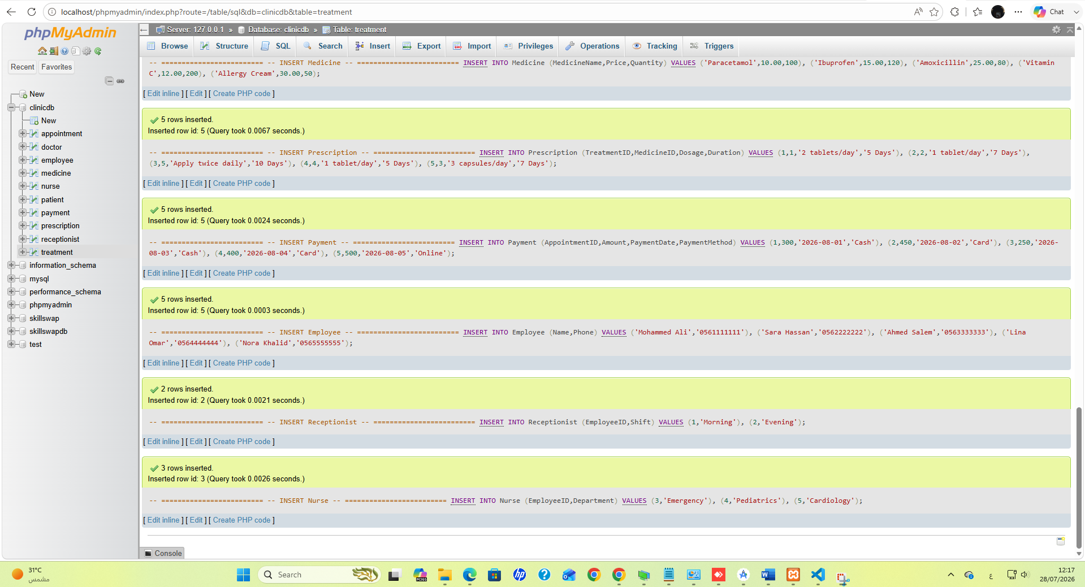
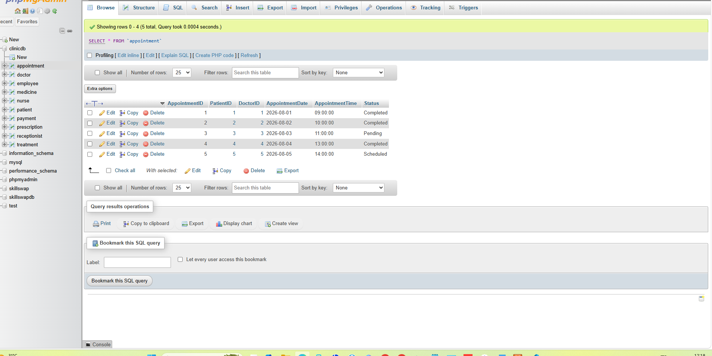
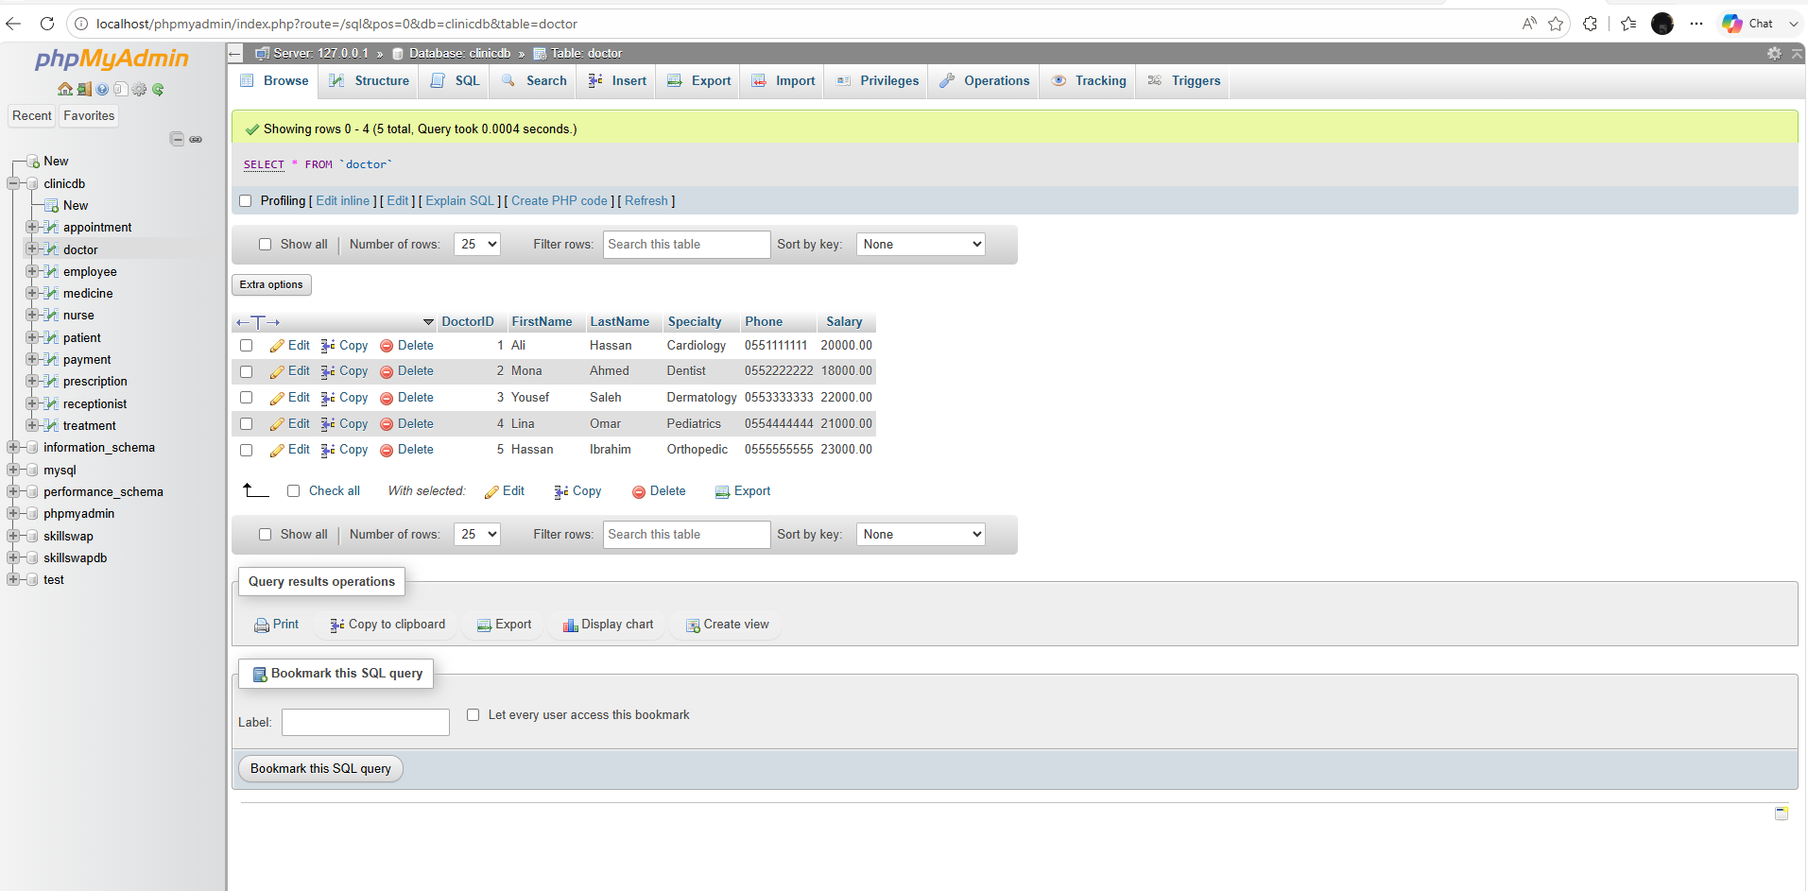
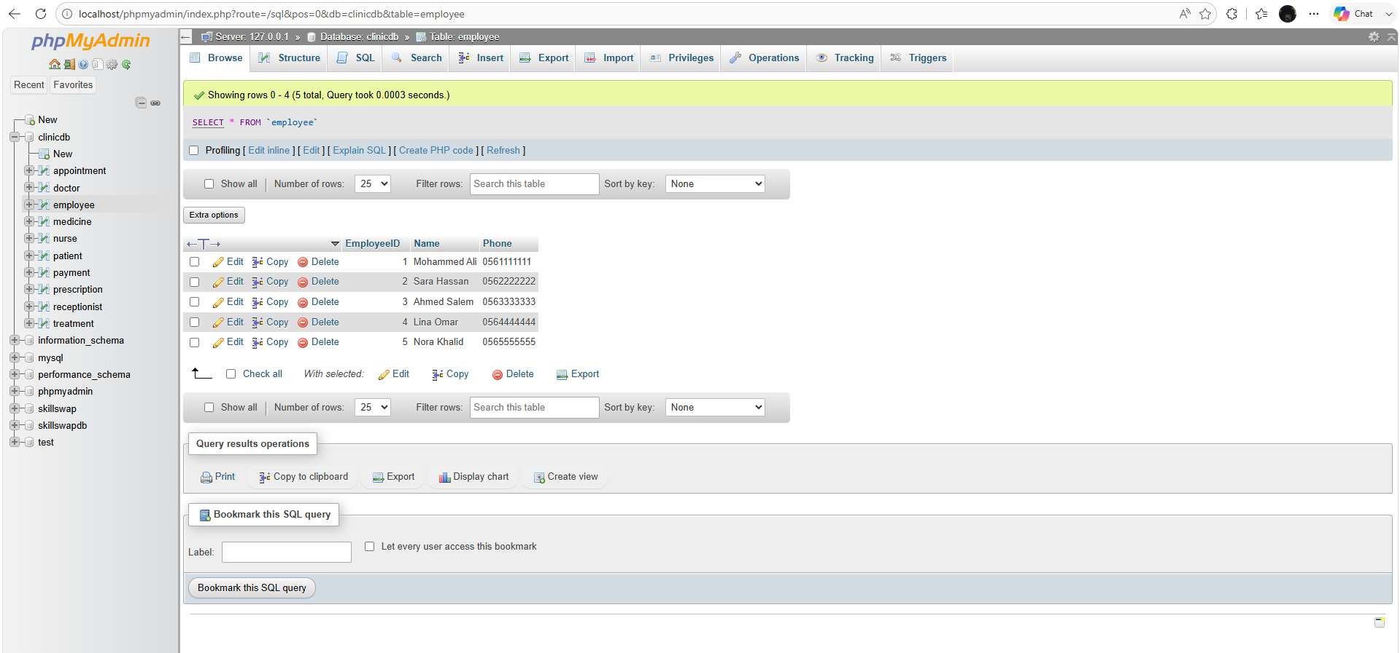
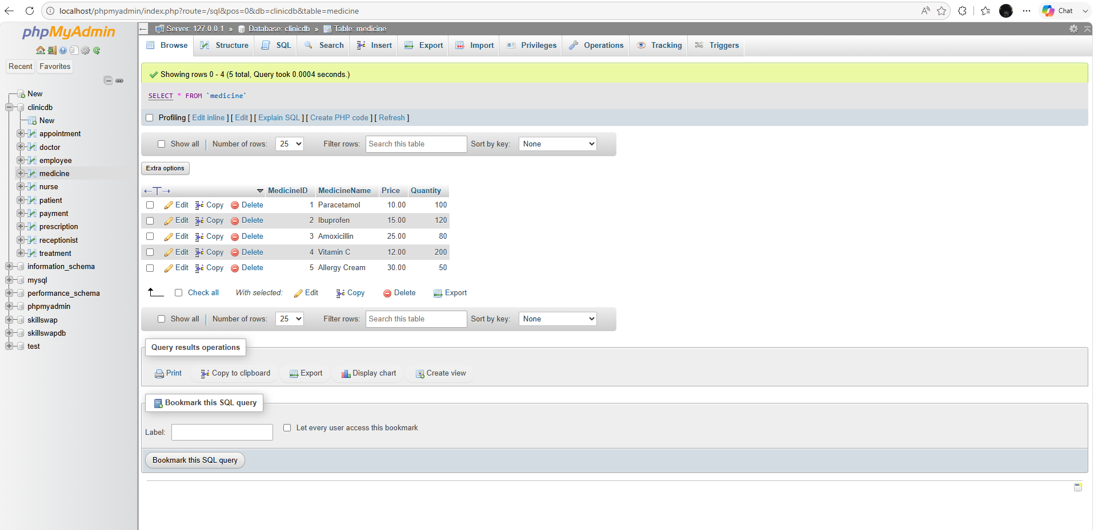
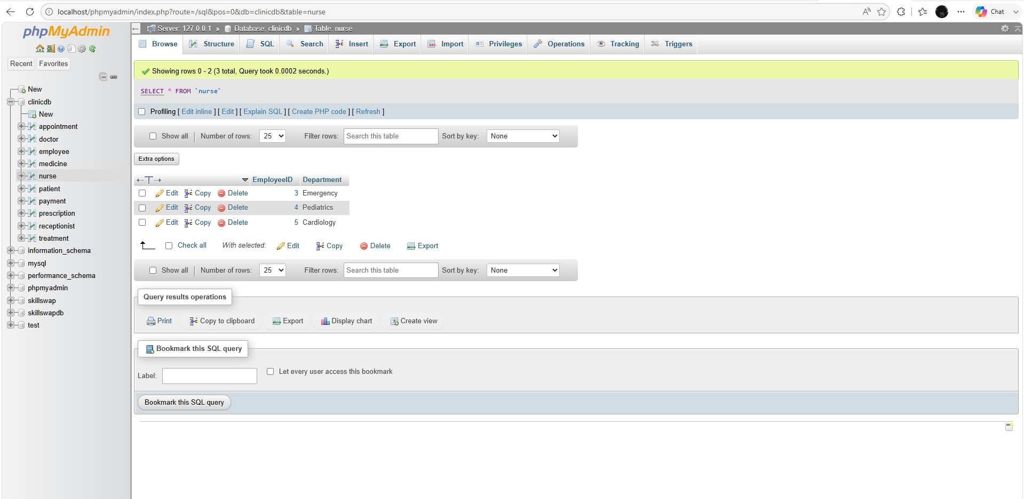
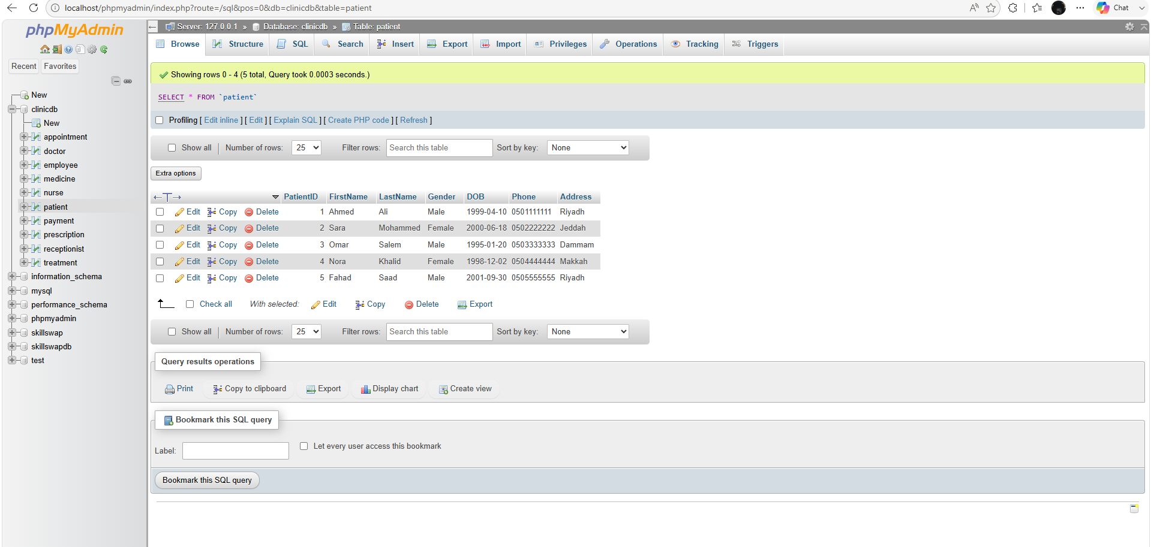
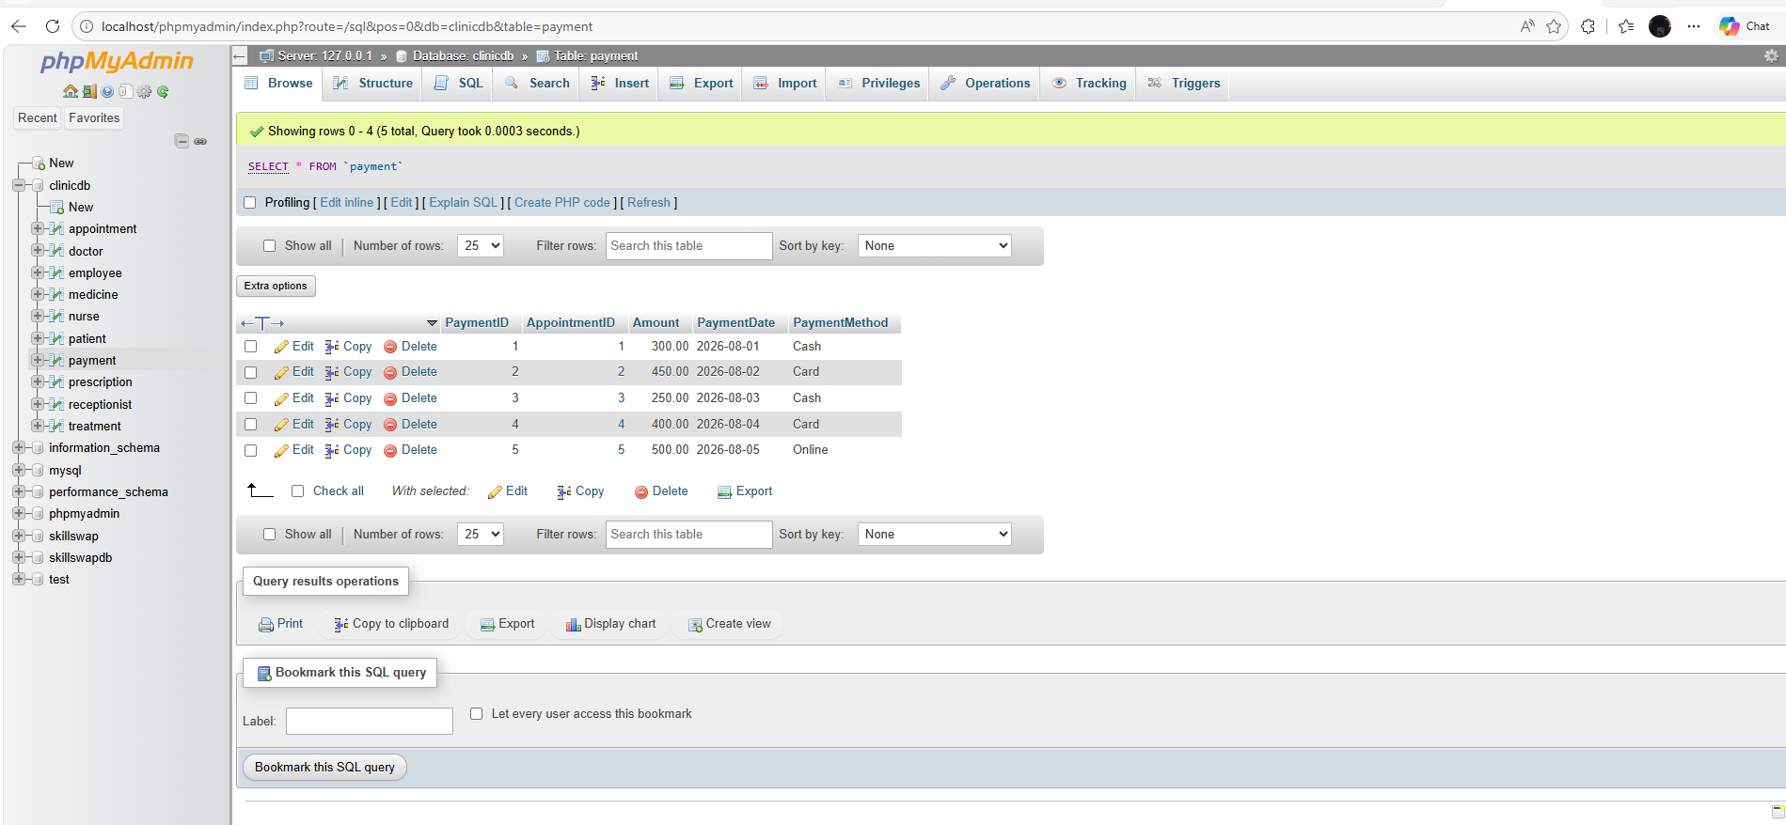
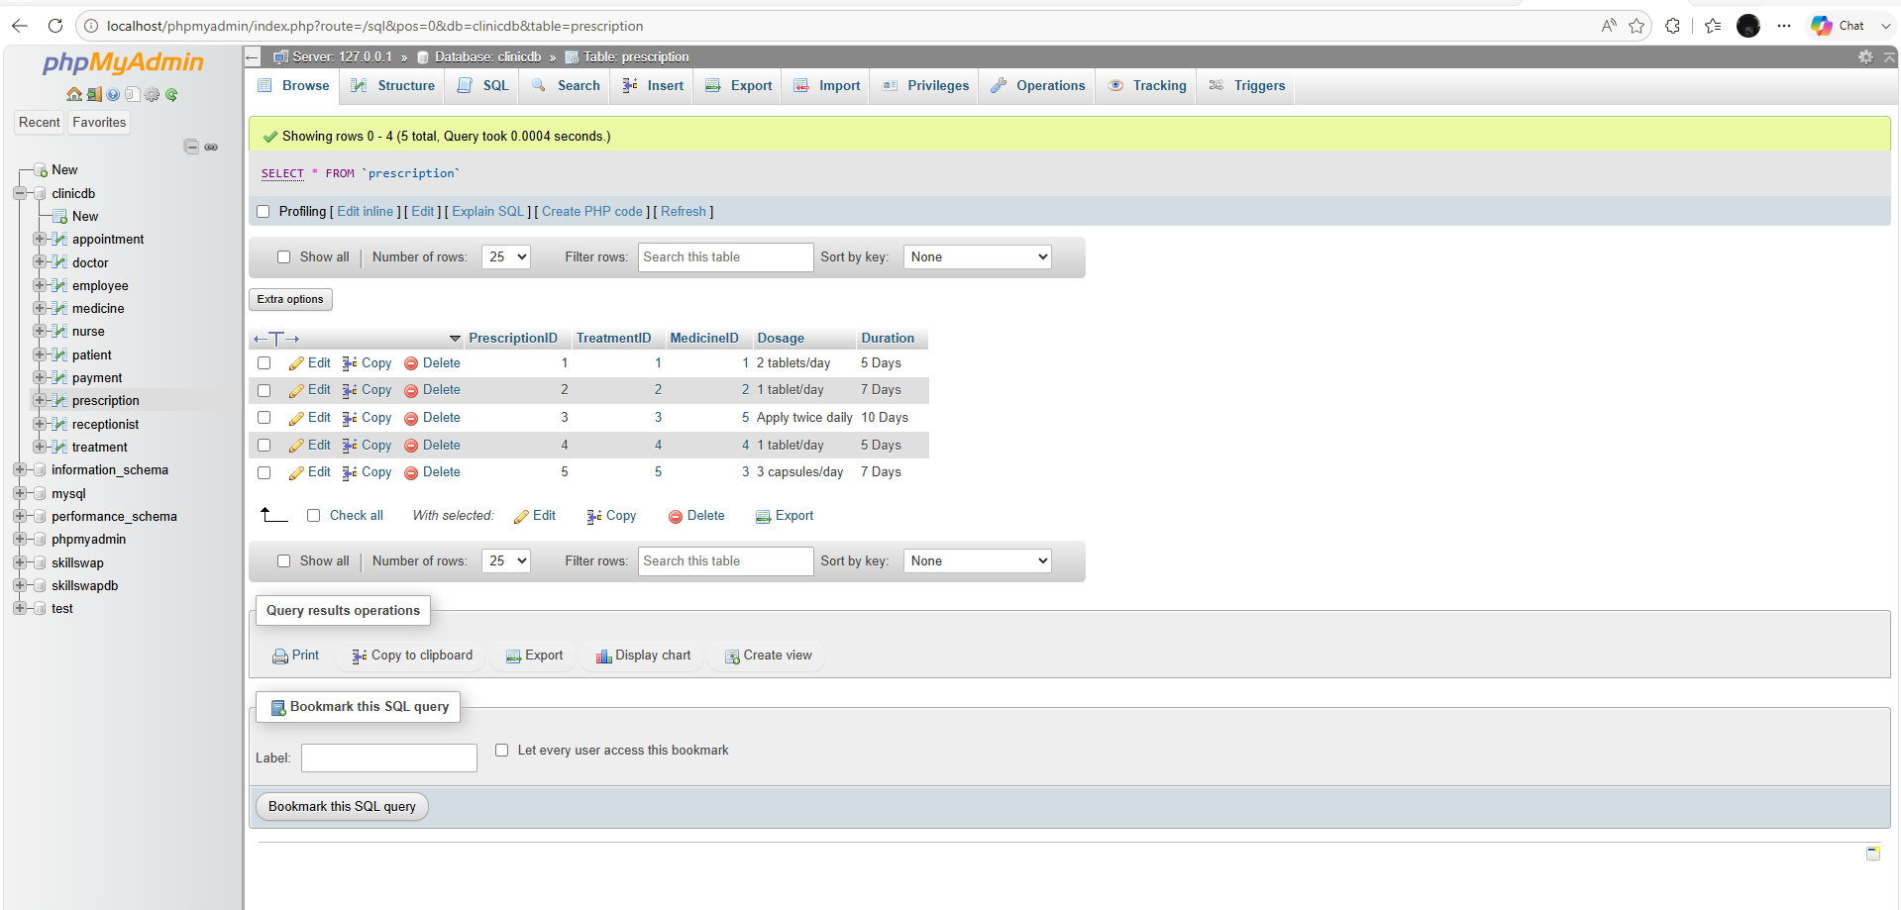
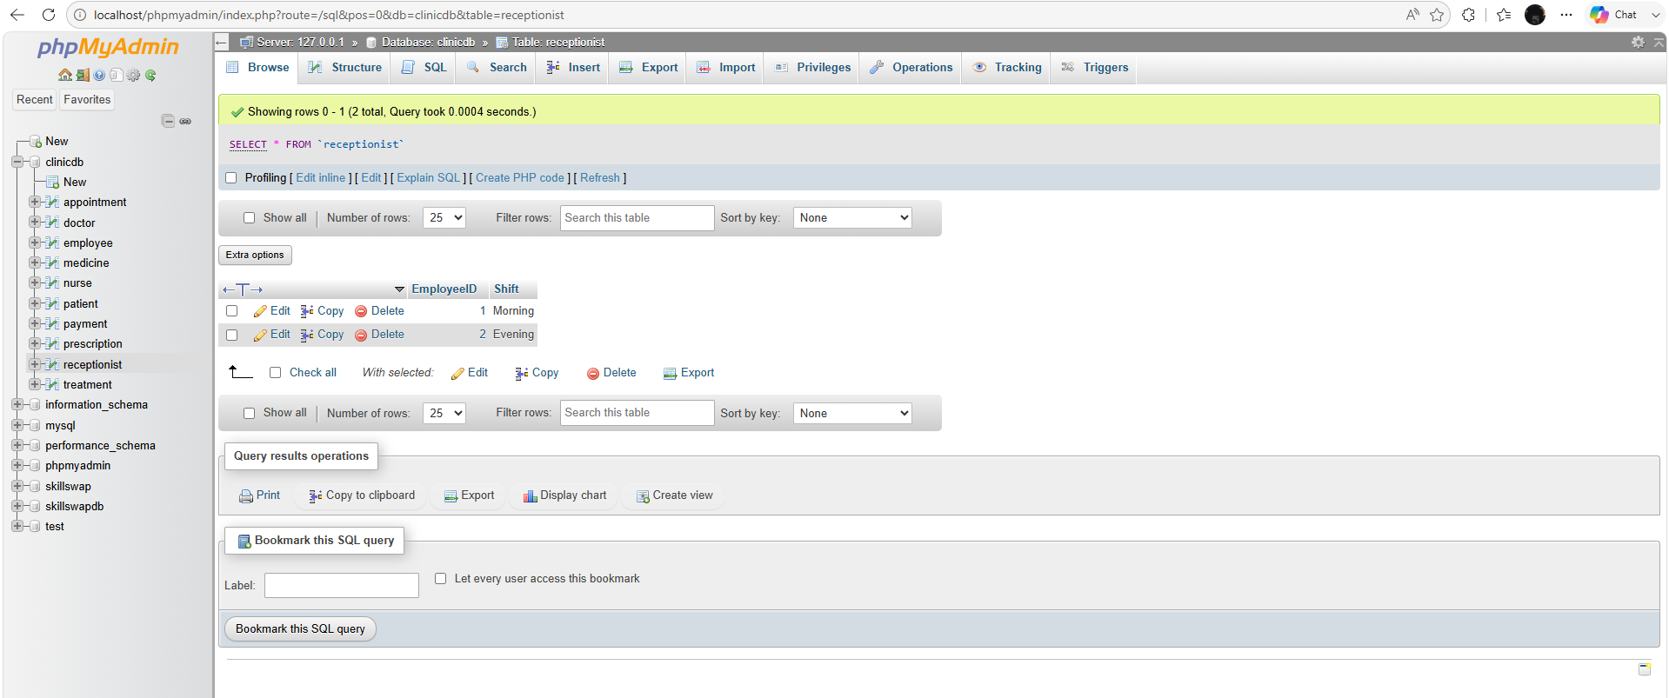
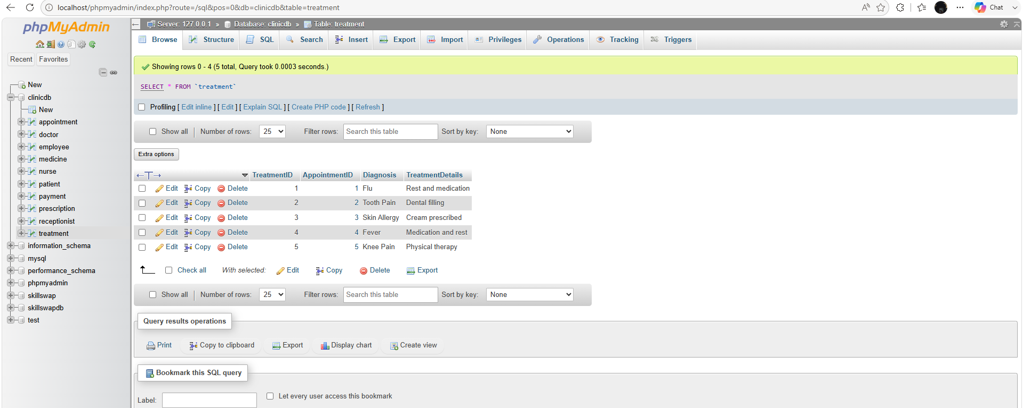

Deliverables
- Project Report (PDF) – System description, ER/EER diagram, relational schema, SQL code, screenshots, and reflection.
- SQL Script (.sql) – Complete SQL implementation of the project.
- GitHub Repository – Repository link with the complete project and commit history.
- Mid-Project Progress Report – Summary of progress, challenges, decisions, and team contributions.
- Project Artifacts
  - Live report document (with edit history): [link]
  - GitHub/GitLab repository (with commit history): [link]
  - Google Colab notebook (if applicable): [link]

